

**BALDIVIS SECONDARY COLLEGE**

**YEAR 11 MATHEMATICS SPECIALIST 2020**

**TEST 1A**

**TOPICS: Combinatorics** (1.1.1 – 1.1.9) and **Proof** (1.3.1 – 1.3.5)

|  |
| --- |
| **INSTRUCTIONS:**  **No Calculator**  **Notes not allowed**  **Full working must be shown for all questions (or parts) worth more than 2 marks.**  **Marks will be deducted for rounding and unit errors.** |
| **Name: Time: 55 minutes Total / 57** |

**Question 1 [ 1, 1, 1 = 3 marks ]**

Simplify, evaluating where possible, the following:

1. 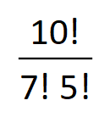 b) 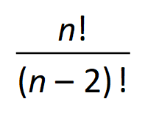 c) 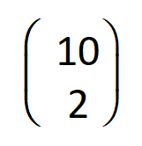

**Question 2 [ 1, 1, 1 = 3 marks ]**

For the statement “If the weather is nice, then I will take a walk” write its:

1. Inverse
2. Contrapositive
3. Converse

**Question 3 [ 2, 2, 3, 3 = 10 marks]**

The digits 0, 1, 2, 3, 4, 5, 6 are to be arranged without repetition to form a 4 digit number which cannot start with 0.

1. How many different arrangements are possible
2. How many arrangements are greater than 3000
3. How many arrangements are even
4. How many arrangement are greater than 3000 or even

**Question 4 [ 1, 1, 2, 2 = 6 marks ]**

A box contains crayons of different colours. There are 5 blue, 3 green, and 2 black. How many crayons must be drawn to ensure that

1. There is 1 blue crayon
2. There are 2 crayons of each colour
3. There is a blue or a black crayon
4. There are more blue than black crayons

**Question 5 [ 2, 2, 2 = 6 marks ]**

A committee of 10 is to be chosen from 7 farmers, 8 grocers and 5 distributers.

Determine the number of ways of selecting the committee if it has to contain:

**[ YOU MAY LEAVE YOUR ANSWERS AS FACTORIALS OR IN THE FORM 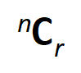 ]**

1. Exactly 3 farmers and 4 grocers
2. Exactly 2 distributers
3. More farmers and grocers (combined) than distributers

**Question 6 [ 6 marks ]**

How many numbers less than 2000 (inclusive) are divisible by 3, 8, or 10

**Question 7 [ 2, 2, 2, 3 = 9 marks ]**

How many ‘words’ can be made from the letters of the word CONTINUOUS, if

**[ YOU MAY LEAVE YOUR ANSWERS AS FACTORIALS OR IN THE FORM  ]**

1. All ten letters are to be used
2. All ten letters are to be used and the letters C and S must be next to each other
3. Five letters are to be used and the word cannot contain more than one of each letter

(i.e. no letter is to be repeated)

1. Five of the ten letters are to be used and the ‘word’ must contain exactly two vowels

**Question 8 [ 4 marks ]**

Decide if the following statement is true or false:

“ Given any 100 consecutive whole numbers, one can choose any 15 numbers so that at least two of the chosen numbers have a difference between them that is always divisible by 7 “

Justify your answer.

**Question 9 [ 4 marks ]**

Show, using proof by contradiction, that if 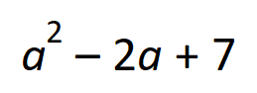 is even, then *a* is odd , *a* is an integer

**Question 10 [ 6 marks ]**

For each of the following statements, state if it is true or fase.

If it is false, provide a counter example

1. If the total exterior angle of a polygon is equal to 360°, then its total interior angle is also

equal to 360°

1. 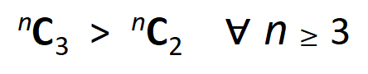
2. 